Assignment 2 due 23/3
  - Construct a sin signal with frequency of 10 (f=10 Hz). Sample it with 5 points/sec (fs = 5 Hz). Plot your result and explain.
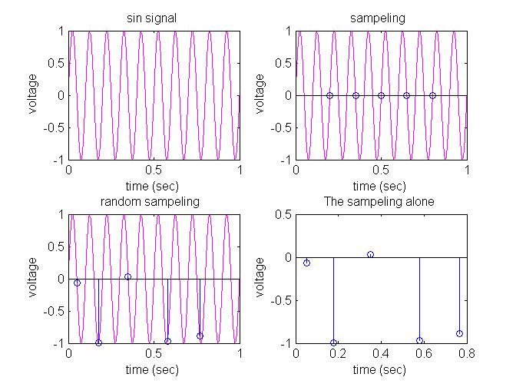
Figure 1 sin signal of10Hz- ther are10 cycles of unit(zero to 2pi) in one sec, with fixed interval sampling and changed interval sempaling.

  - A recording electrode has 3MΩ impedance. What should be the preamplifier impedance so that the difference between the measured V and the original voltage will be less than 1 %.
$$V^{'}=\frac{RiV}{Ri+R0} R0=3, 0.9{<V}^{'}<1.1V→0.9V<\frac{RiV}{Ri+3 }<1.1V$$
$$0.99<\frac{Ri}{Ri+3}<1.01→0.99Ri+2.97<Ri<1.01Ri+3.03$$
$$297<Ri or Ri<-303 , ∀R>0 → 297MΩ<Ri$$

  - How many bits we need to use to get a resolution of 1uv if the range is ±5V and we amplify the signal by 10000. Note that we want to utilize the full range
$$n=\log_{2}{\frac{R}{Q }} →R=\frac{5-(-5)}{10000}\left[V\right]=0.001\left[V\right], Q={10}^{-6}\left[V\right]→n=\log_{2}{\frac{{10}^{-3}}{{10}^{-6}}=\frac{\log{1000}}{\log{2}}}=9.9657=\sim 10$$

4.A student forgot to amplify a signal in a -5 to +5 volt system. Its sampling resolution is 12 bits. The sampling rate is 30kHz. How many different points will he/she have for a 1ms action potential as in the picture?
$$Q=\frac{R}{2^{n}}=\frac{5-(-5)}{2^{12}}=0.002441\left[V\right]=2441\left[µV\right]$$
The signal range is 160[$µV$] , so although the student is sampling 30 times in this ms, so the sexually confused student will get no values what or ever.

1ms
150 uv
-10 uv

